TITLE OF PAPER (max 100 characters; Calibri, 14pt bold)

**Authors’ name** (full names; Calibri 11pt bold, with **presenting author underlined**) e.g.,

**Yongseok Hong1, Jung-Hwan Kwon1, Jeong-Eun Oh2, Hyo-Bang Moon3 and Tae-Young Kim3**

Affiliations (Calibri 10pt ) e.g.,

1 School of Environmental Engineering, Korea University, Korea

2 Life Sciences School, Pusan National University, Korea

3 Dept. of Civil, Chemical, and Environmental Engineering, Hanyang University, Korea

*Corresponding author email:* [yongseokhong@korea.ac.kr](mailto:yongseokhong@korea.ac.kr)

ABSTRACT (Calibri, 12pt bold)

This is the executive summary of your presentation. It should **not** exceed ONE PAGE (size A4 with 2.2 cm top, left, right and 1.8 cm bottom margins) and it should include the background of the work and its objectives, the methods/techniques used, the main results obtained, and the conclusions drawn.

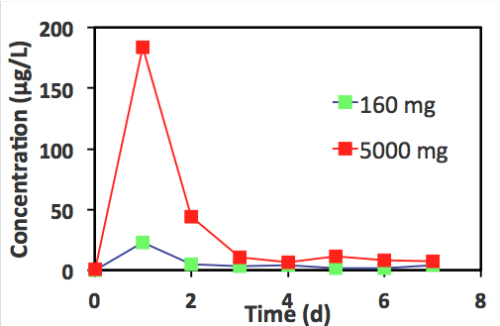Please pay attention not to elaborate too much on the background. Background should be less than ¼ of the summary. The text of the executive summary should be written in single space, **Calibri 11pt**. You should leave **6pt between paragraphs with no indentation**.

You **may** include one or more diagrams, if so desired – respecting the one-page limit.

You may include a few important references if desired and acknowledgement to funding sources.

***Acknowledgements:*** The financial support by …. is greatly appreciated.

***References:***

**(If needed,** References should be written in single space and in alphabetical order, font **Calibri 10pt)**

Syranidou, E., S. Christofilopoulos, M. Politi, N. Weyens, D. Venieri, J. Vangronsveld and N. Kalogerakis “Bisphenol-A removal by the halophyte Juncus acutus in a phytoremediation pilot: Characterization and potential role of the endophytic community”, *J. Hazard. Mater*., 323: 350–358 (2017).

**\*\*\*\*\* Abstract should not exceed one page \*\*\*\*\***

The abstract format guidelines are summarized in the following Table:

|  |  |
| --- | --- |
| **Item** | **Format Guideline** |
| Page size | A4 (297mm by 210 mm) – vertical orientation |
| Margins | Margins 2.2 cm top, left, right and 1.8 bottom |
| Length | The abstract should ONE PAGE long. |
| Layout | **Title:** 14 pt Calibri Font, bold, upper case  **Author names:** 11 pt Calibri Font, bold  **Presenting author:** Underlined  **Affiliations:** 10 pt Calibri Font  **Body text:** 11 pt Calibri Font, Potential Sub- Heading, justified  **Acknowledgements:** 11 pt Calibri Font, justified  **References**: 10 pt Calibri Font, justified |